All Server Active Directory Snippet:

Oshawa:

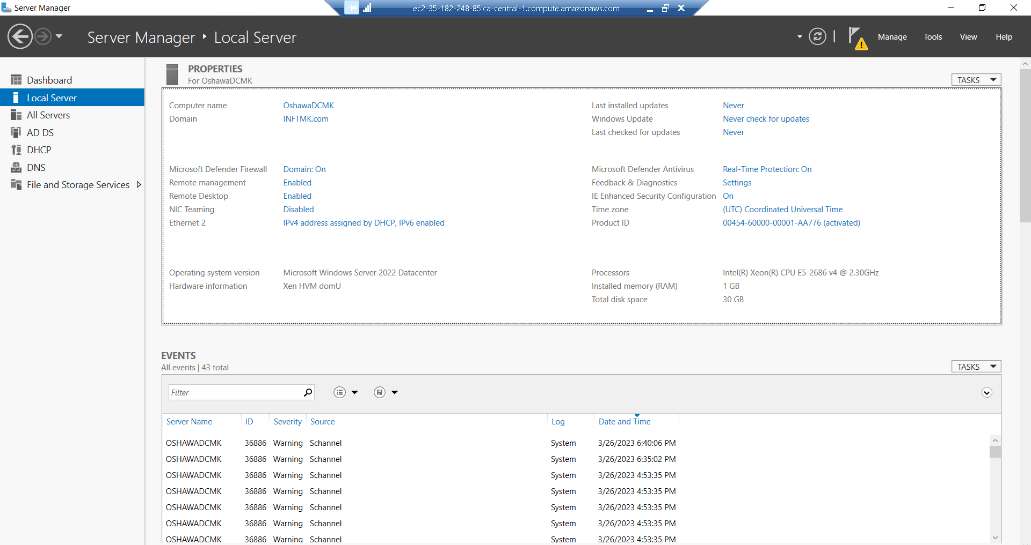

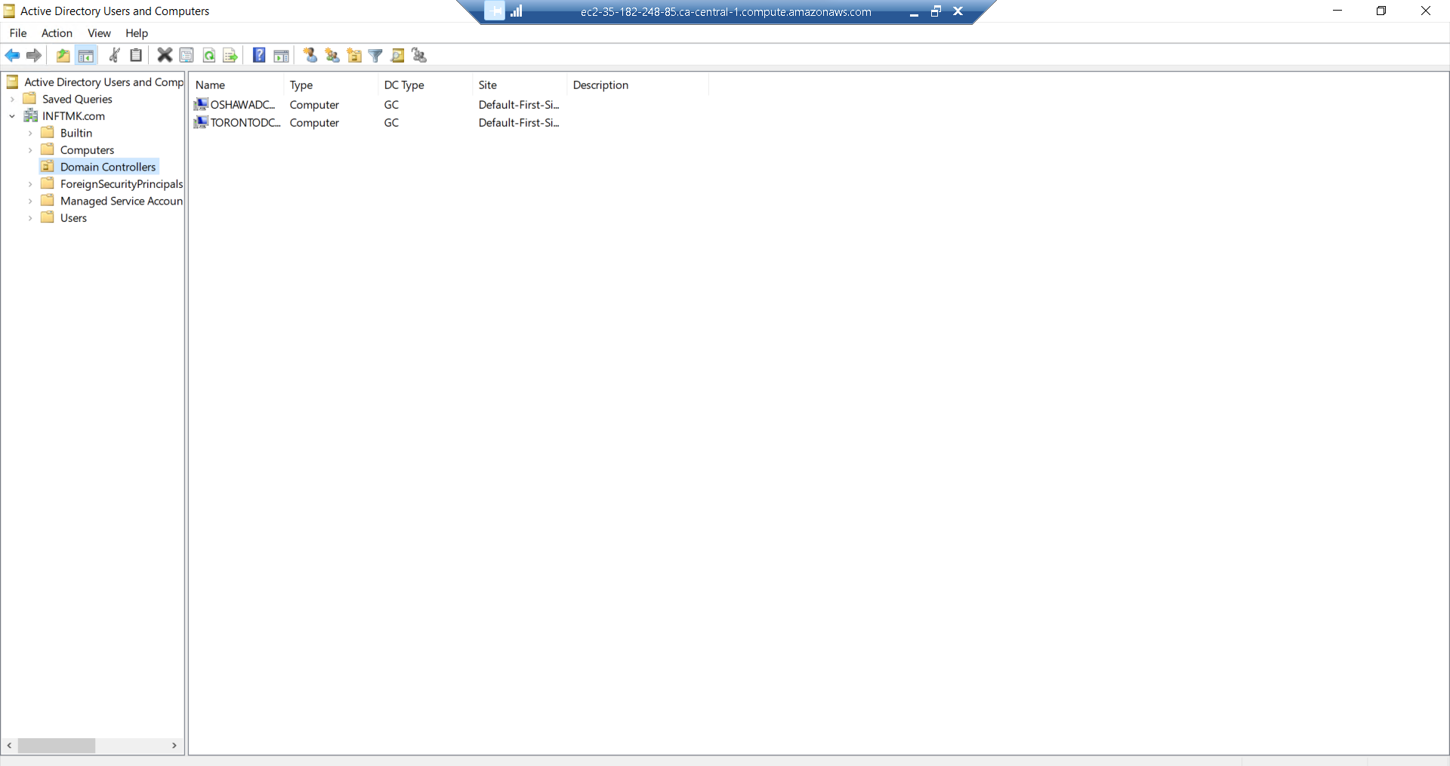

Toronto Server

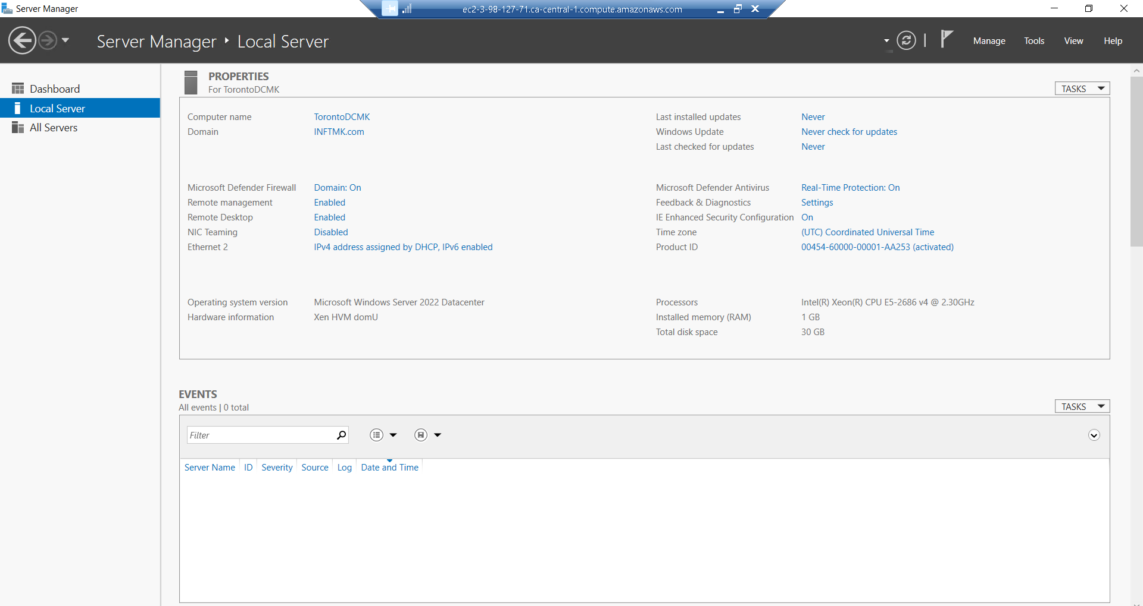

File server:

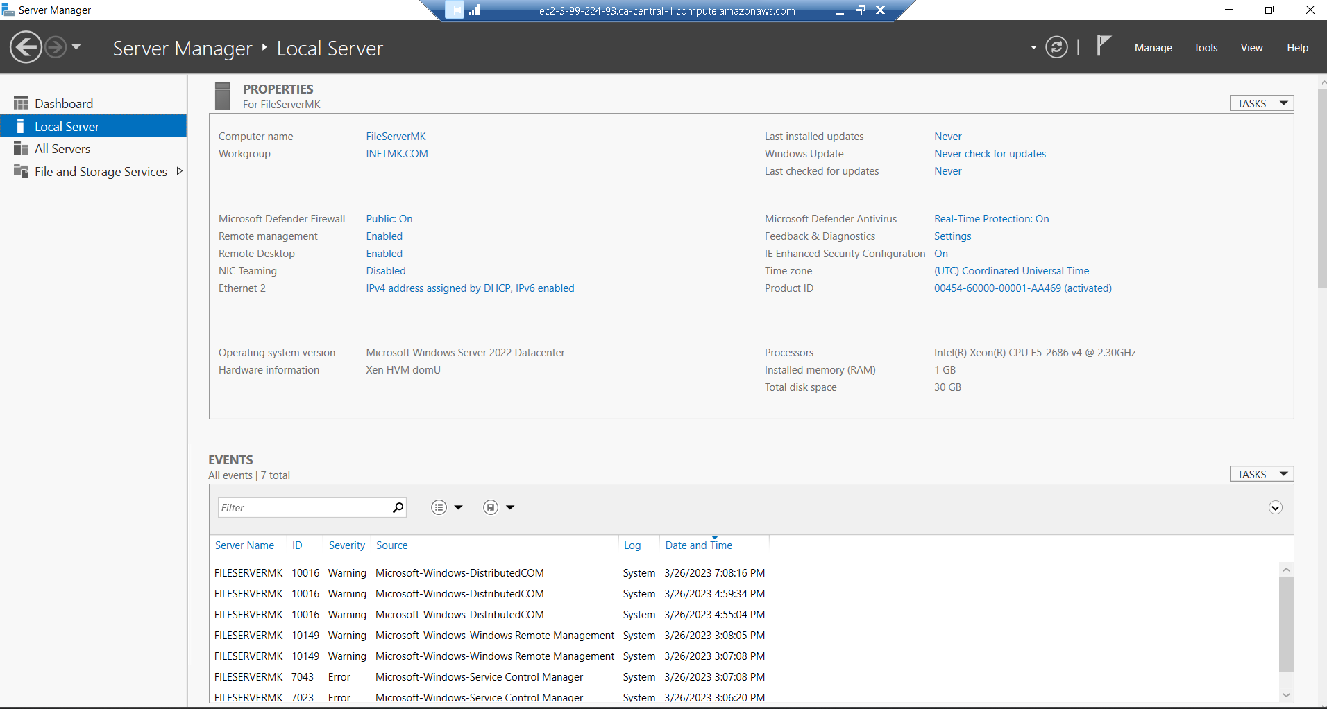

DNS Oshawa

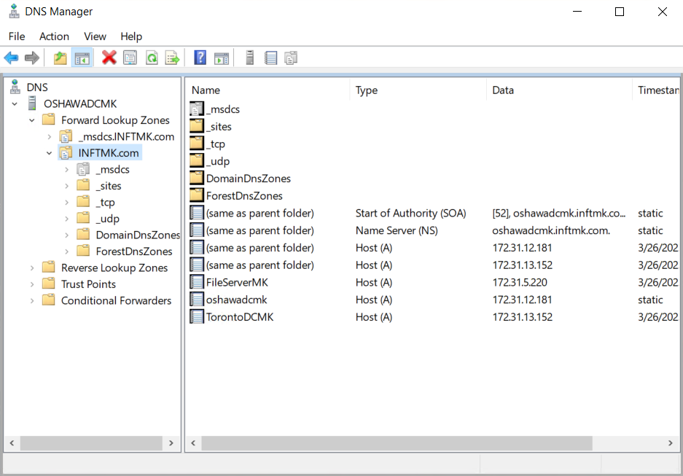

Question: What is in common among the instance on every screenshot.

All these servers are in same Domain, which means all these servers are in same network. There are few security group and DNS configuration changes is require to make this happen.